**My Report**

<http://myreport.esds.co.in/login/login.php>

1. Login with your AD Username and Password

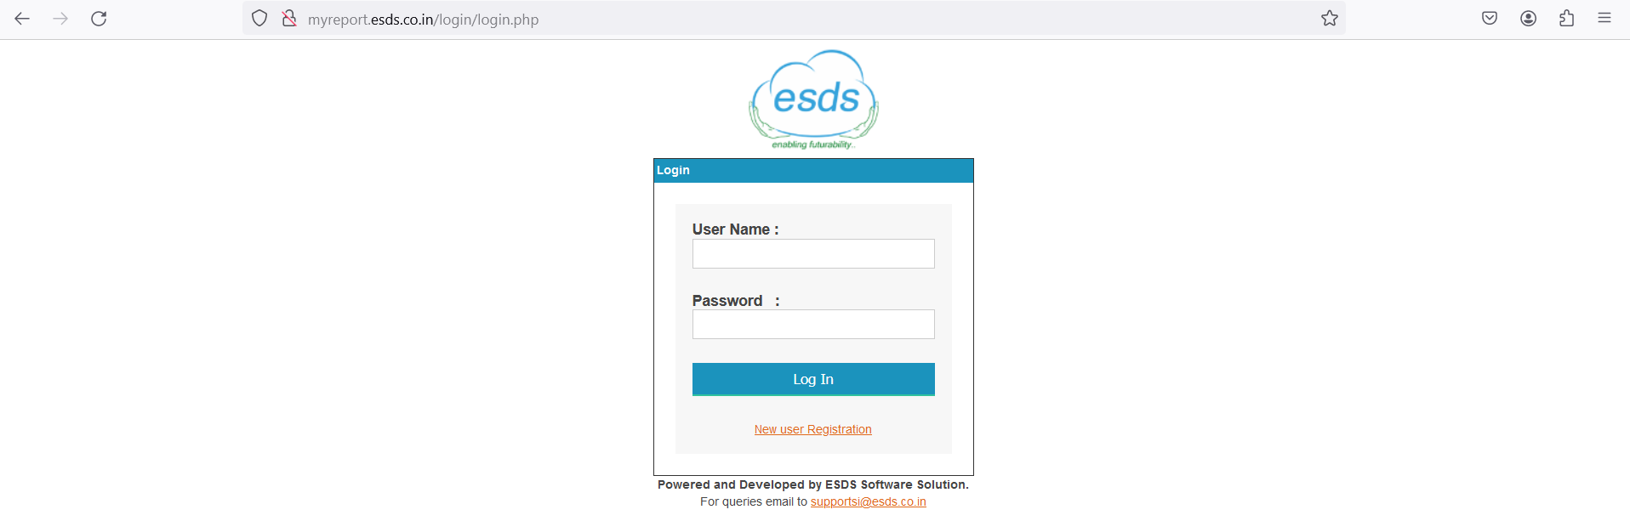

Once login it gives the status details of your shift as well as the list of different team member who is in shift, Ticket SLA details, Open/ In Progress/ on hold tickets

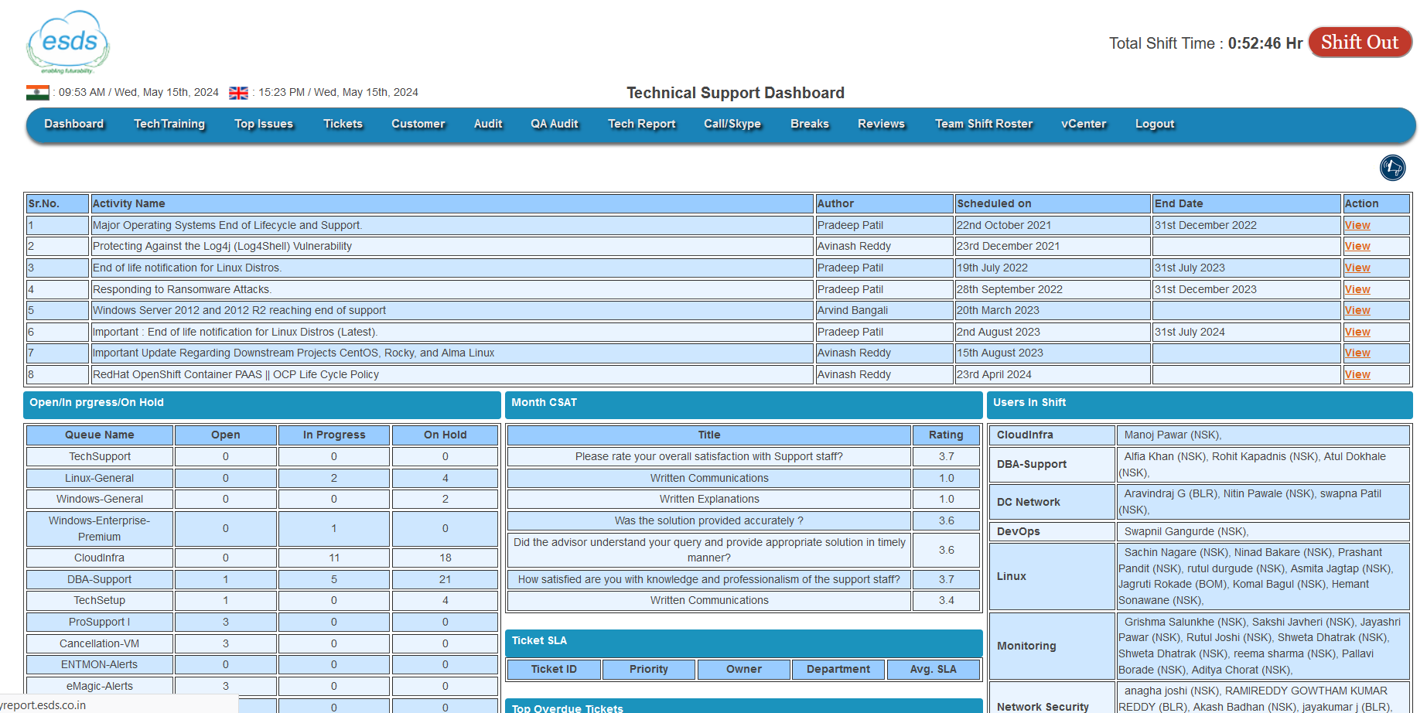

1. In dashboard we can see own monthly report, daily attendance, tickets, task details, etc. etc.

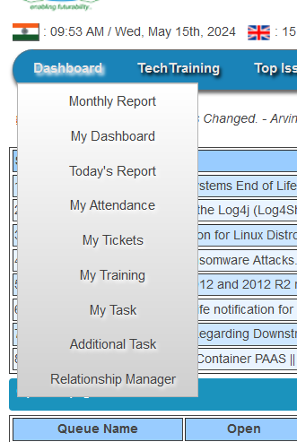

1. Break: While for breakfast or lunch/dinner you have to apply break on portal by clicking Add Self Break

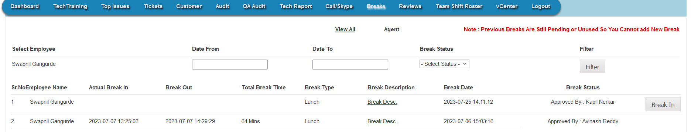

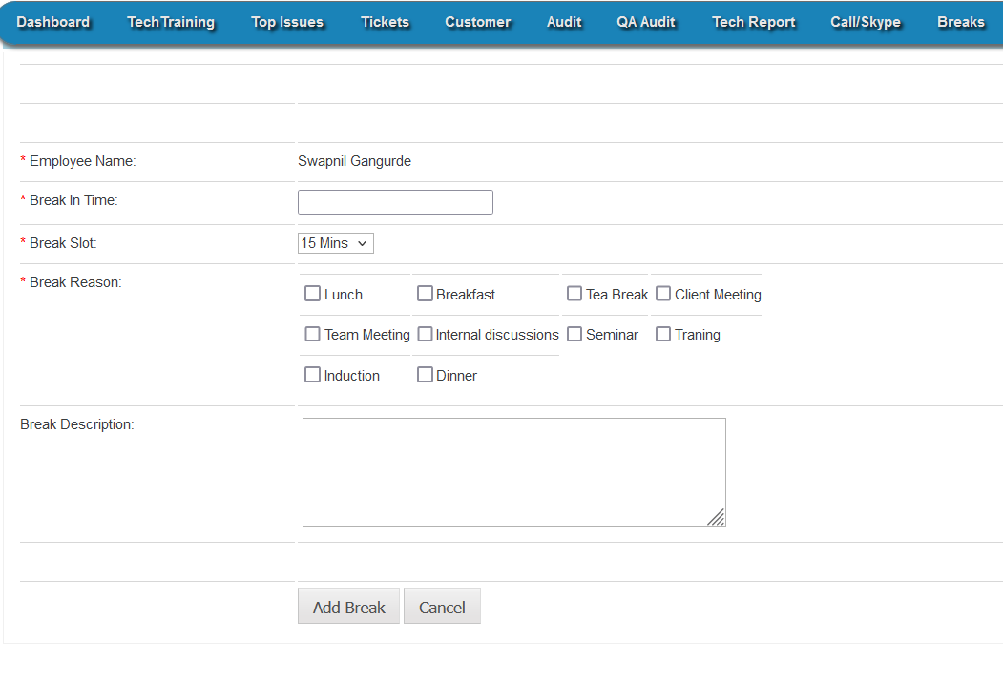

1. Once you done with your shift kindly click on shift out

